Unit 5 — Mining Data Streams

Study Notes
Syllabus covered: Introduction to Streams Concepts, Stream data model and architecture, Stream Computing, Sampling data in a stream, Filtering streams, Counting distinct elements in a stream, Estimating moments, Counting ones in a window, Decaying window, Real Time Analytics Platform (RTAP) applications — case studies: real-time sentiment analysis, stock market predictions

Part A — Stream Concepts, Model & Architecture

1. Introduction to Stream Concepts

What is a Stream?
- A stream refers to a sequence of data elements or symbols made available over time.
- A data stream transmits from a source and is received/processed at a processing end ("sink") in a network.
- It is a continuous flow of data between the source and receiver ends, processed in real time.
- In a computing/programming sense, a stream also refers to the communication of bytes or characters over sockets in a network, and is used as an underlying data type in inter-process communication channels.
Key idea: Unlike a stored dataset (which is data at rest), a stream is data in motion — it keeps arriving, is typically unbounded in size, and generally must be processed as it arrives rather than after being fully collected.
Examples of Data Stream Applications
- Real-time, data-driven marketing decisions — using real-time sales trend analysis, social media analysis, and sales distribution data as it streams in.
- Network management / system monitoring — monitoring and detecting potential system failures using network management tools.
- Industrial/manufacturing monitoring — real-time monitoring of machinery on a production line.
- Sensor networks / IoT — a set of sensors or IoT devices, controlled by one or more entities, continuously emitting readings.
- Streaming media — watching online video lectures, with rewind/forward interactions generating an interaction stream.
How Stream Applications Process Data
- Processing happens in micro-batches rather than large, infrequent batches.
- Analogy: stream processing is like filling milk bottles on a conveyor belt and capping them one at a time, successfully, rather than filling one giant batch container all at once. Small, continuous units of work flow through the system rather than data being processed only after it has all piled up.

2. Stream Data Model and Architecture
Data Stream Model
- A stream is data in motion.
- There are three broad approaches for updating the end-points (sinks):
  - Non-overlapping — each piece of output/update is independent.
  - Slow (batch processing) — updates happen periodically, after data accumulates.
  - Fast (near real-time) — updates happen continuously, close to the moment data arrives.
- There are several different ways to model a data stream — how it is represented, queried, processed, and managed. The main models are below.
(a) Graph-based Stream Data Model
A simple conceptual model of stream processing:
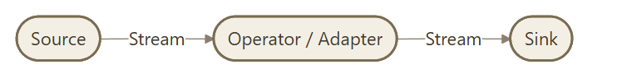
- Source — where the stream originates (a sensor, application, log generator, etc.)
- Operator/Adapter — a processing node that transforms, filters, or aggregates the stream as it passes through.
- Sink — the destination/consumer of the processed stream (a store, dashboard, alerting system, etc.)
(b) Relation-oriented Stream-Tuples Model
- Stream dataflow can be modeled as a flow of tuples.
- Individual data items are treated as relational tuples — similar to rows in a database table.
- A data stream S is modeled as an infinite, time-ordered multiset of tuples, each represented as (Timestamp τ, Key, Values), flowing from a Source Stream to a Sink (which might be a Parquet nested column-oriented store or an RDBMS tabular store).
- Data Stream (formal view): An unbounded, time-ordered sequence of data items (relational tuples).
  - The receiving software receives the tuples in order and sees each data item only once (it typically cannot "go back" and re-read an earlier tuple the way it could query a stored table).
  - Each tuple has a set of attributes, similar to a row in a database table, giving it a schema-like structure similar to a traditional database.
  - One attribute in the tuple's schema is always a timestamp, usually denoted t (or τ) — this is what makes real-time ordering and windowing possible.
(c) Data Source and Sink
- The Data Source may be an RDBMS row-oriented storage table or a Parquet table.
- Parquet is a nested, hierarchical, columnar-storage format. Its nesting sequence is: table → row groups → column chunk → page chunks (within the column chunk).
- Data flows from source, through processing, into a Data Sink (the final destination/consumer).
(d) Object-based Data Stream Model
- Data-flows are modeled as a stream of objects.
- Examples:
- Cougar — models sensor data as a stream of objects.
- Tribeca — models network monitoring data as a stream of objects.
(e) XML-based Data Stream Model
- Example: NiagaraCQ — an XML-based data stream model.
- Supports scalable continuous query processing over XML documents.
- Handles millions of simultaneous queries efficiently by dynamically grouping them according to their structural similarities.
(f) Window-based Data Stream Model
- Since a stream is unbounded, algorithms usually only look at a window — a defined portion of the stream — at any given time, rather than the entire (infinite) history.
- Stream data can be directed toward:
- A fixed window — a window of fixed size that does not move once set.
- A sliding window — a window of fixed size that continuously moves forward as new data arrives, always covering "the most recent N items/time units."
- A landmark window — a window that starts from a fixed reference point ("landmark") and grows as new data arrives, rather than sliding.
- (See "Counting Ones in a Window" and "Decaying Window" below for concrete window-based algorithms.)
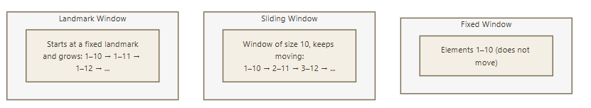
Summary of Part A: A data stream is a continuous, real-time flow of data between source and sink, seen only once and processed as it arrives. It can be modeled as a graph (source → operator → sink), as relational tuples with timestamps, as objects, as XML, or through a windowing lens — each suited to different querying, processing, and management needs.

Part B — Stream Computing

3. Stream Computing — Concept
Stream Computing is a computing paradigm designed to process continuously arriving data ("data in motion") with low latency, as opposed to storing all data first and processing it later in bulk.
Aspect | Batch Computing | Stream Computing
Data state | Data at rest (already stored) | Data in motion (arriving continuously)
Processing trigger | Scheduled/periodic job | Continuous, event-driven
Latency | High (minutes to hours) | Low (milliseconds to seconds)
Data seen | Multiple times (can re-query) | Typically only once, in order
Memory | Entire dataset can reside on disk | Must work with limited memory since the stream is unbounded
Example tools | Hadoop MapReduce | Spark Streaming, Apache Storm, Flink, Kafka Streams

Key characteristics/constraints of stream computing:
- Unbounded data — a stream, in principle, never ends, so it is impossible to store the entire stream and impossible to wait for "all" the data before processing.
- One-pass processing — algorithms typically get to look at each data item only once; they cannot go back and re-scan.
- Limited memory — since the stream is unbounded but memory is finite, algorithms must summarize/approximate rather than store everything exactly. This motivates the family of streaming algorithms covered in Part C (sampling, filtering, counting distinct elements, estimating moments, counting ones in a window) — these all trade a small, controlled amount of accuracy for a huge reduction in memory usage.
- Real-time response — results must typically be available quickly enough to be actionable (e.g., fraud alerts, trending topics, live dashboards).
- Fault tolerance and ordering — the processing engine must handle out-of-order or delayed data and recover gracefully from failures without losing or duplicating results.

Part C — Core Streaming Algorithms
Because a stream is unbounded and memory is limited, exact computation over "all data seen so far" is often impossible. This part covers the classic techniques for approximating key statistics over a stream using bounded memory.

4. Sampling Data in a Stream
Why sample? Since a stream cannot be fully stored, we often want to maintain a representative random sample of a fixed size from the stream so that later queries/analysis can be run on the sample instead of the full stream.
The challenge: The stream's length is unknown in advance, and every element should have an equal probability of being part of the final sample — a naive "pick the first N elements" or "pick every Kth element" approach is biased and does not give a fair random sample once the stream keeps growing.

Reservoir Sampling (the standard technique)
- Goal: maintain a sample of exactly k elements from a stream of unknown/unbounded length n, such that every element has an equal k/n probability of being in the final sample.
- Algorithm:
  - Place the first k elements of the stream directly into the "reservoir" (the sample).
  - For each subsequent element (the i-th element, where i > k):
    - Generate a random number r between 1 and i.
    - If r ≤ k, replace the element currently at position r in the reservoir with the new (i-th) element.
    - Otherwise, discard the new element.
  - At any point (or at the end), the reservoir contains a uniform random sample of size k from all elements seen so far.
- Why it works (intuition): At each step, the probability that any specific earlier element survives to remain in the reservoir works out to be exactly k/i at step i, and this remains true for every element regardless of when it arrived — so the sample stays uniformly random as the stream grows.
- Use case example: Maintaining a random sample of user search queries out of a search engine's unbounded query stream, for later ad-hoc analysis, without having to store every query ever issued.

5. Filtering Streams
The problem: Given a stream of items, we often want to test membership — "has this item been seen before?" or "does this item belong to a known set S (e.g., a blocklist, a set of valid users)?" — without storing the entire set S or the entire stream, because both can be far too large for memory.
Bloom Filter — the standard solution
- A Bloom filter is a space-efficient probabilistic data structure used to test whether an element is a member of a set.
- It can produce false positives (incorrectly saying an item IS in the set when it isn't) but never false negatives (if it says an item is NOT in the set, that is always correct).
Structure:
- A bit array of size n, initialized to all 0s.
- k independent hash functions, each mapping an input item to one of the n array positions.
Adding an item to the set (building the filter):
  - Pass the item through all k hash functions, producing k positions in the bit array.
  - Set the bit at each of those k positions to 1.
Checking membership of an item:
- Pass the item through the same k hash functions to get k positions.
- If all k positions are set to 1 → the item is possibly in the set (could be a false positive due to hash collisions from other items).
- If any one of the k positions is 0 → the item is definitely not in the set (no false negatives).
Example (small scale):
- Bit array of size 10, all bits = 0.
- Adding "apple" using 2 hash functions might set bits 2 and 5 to 1.
- Adding "banana" might set bits 5 and 8 to 1.
- Checking "apple" → checks bits 2 and 5 → both 1 → reported as present (correct).
- Checking "cherry" → if it happens to hash to bits 2 and 8 (both already set by other words) → it would be incorrectly reported as present — a false positive.
Trade-offs:
- Very memory-efficient compared to storing the actual set (uses a fixed-size bit array regardless of how many items are added).
- False-positive rate increases as more items are added to the filter (the array gets more "crowded" with 1s) — can be controlled by choosing an appropriately large bit array and the right number of hash functions for the expected number of items.
- Cannot delete items from a standard Bloom filter (removing a bit could break membership tests for other items that share that bit).
Use cases: Web crawlers checking "have I already visited this URL?", spell-checkers, spam/malicious-URL blocklists, caching systems checking "is this item worth fetching from a slow backend?", and network routers filtering packets.

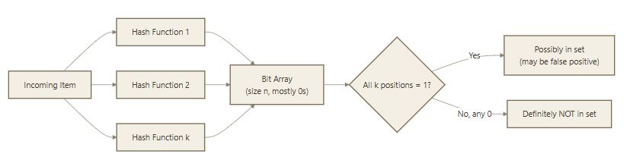

6. Counting Distinct Elements in a Stream

The problem: Count the number of distinct elements seen in a stream (e.g., number of unique visitors to a website, number of distinct search queries), without storing every distinct element that has appeared (which could require huge memory for a long stream with many unique items).
Flajolet–Martin (FM) Algorithm — the standard solution
- A probabilistic algorithm that estimates the count of distinct elements using very little memory, at the cost of some estimation error.
Core idea:
- Use a good hash function h that maps each stream element to a binary number (a bit string), such that the hash values are roughly uniformly distributed.
- For each element in the stream, compute h(element) and find r(element) = the position of the rightmost/trailing 0 followed by all-1s pattern — in the simplest description, the number of trailing zeros in the binary hash value (i.e., the position of the lowest-order 1 bit).
  - Example: h(x) = 101000 (binary) → trailing zeros = 3.
- Keep track of R = the maximum number of trailing zeros seen so far across all elements processed.
- Estimate of distinct count ≈ 2^R
Intuition: If a hash function distributes values uniformly at random, the probability that a random hash value ends in exactly r zeros is 1/2^r. So among m distinct elements, we'd expect to see a value with r trailing zeros roughly when m ≈ 2^r. The largest R observed therefore gives a rough (but unbiased-in-expectation, when properly averaged) estimate of the number of distinct elements — 2^R.

Refinements used in practice: A single hash function gives a noisy estimate (it can be off by a large factor), so real implementations use many independent hash functions in parallel and combine their estimates (e.g., by grouping them and taking the median of means, or similar combining strategies) to reduce the variance and get a more accurate final estimate. (This underlying idea is also the basis of the modern HyperLogLog algorithm used in production big data systems.)

Use case example: Estimating the number of unique users who visited a website in a day, or the number of distinct IP addresses that have connected to a server, using only a small, fixed amount of memory even if millions of users are involved.
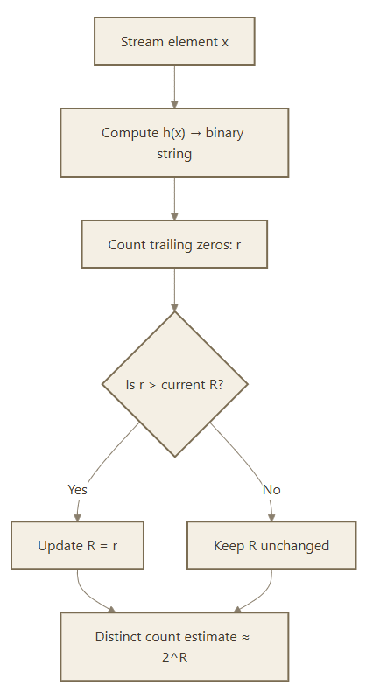

7. Estimating Moments

What are "moments" of a stream? Given a stream of items drawn from a universe of possible values, let m_i be the number of times value i has occurred so far. The k-th moment of the stream is defined as:

Moment_k = Σ (m_i)^k (summed over all distinct values i that have appeared)
- 0th Moment (k = 0) — Σ (m_i)^0 = the count of distinct elements in the stream (this is exactly the problem the Flajolet–Martin algorithm above solves).
- 1st Moment (k = 1) — Σ (m_i)^1 = the total length of the stream (total number of elements seen, counting repeats) — this is trivial to compute exactly with a single counter.
- 2nd Moment (k = 2) — Σ (m_i)^2 = a measure of how skewed/non-uniform the distribution of values is (also called the surprise number). A stream where one value dominates has a much higher 2nd moment than a stream where all values occur about equally often, for the same total count.

AMS Algorithm (Alon–Matias–Szegedy) — estimating higher moments with limited memory
Used to estimate the 2nd moment (and higher moments) without storing counts for every distinct value.
Algorithm (conceptual steps):
- Pick a random position/timestamp t in the stream (uniformly at random from the positions seen so far — done as the stream is being processed, similarly in spirit to reservoir sampling).
- Let X.el = the value of the stream element at that randomly chosen position t.
- Let X.val = the count of how many times X.el appears from position t to the end of the stream (i.e., count forward from the sampled position).
- Compute the estimate for the 2nd moment from a single variable as: Estimate = n × (2 × X.val − 1), where n is the total length of the stream so far.
- In practice, maintain many independent copies of such a variable X (each sampled at a different random position) and average their estimates to reduce variance and get a more reliable final answer.
General form for the k-th moment: the same approach generalizes — using X.val^k − (X.val − 1)^k in place of 2 × X.val − 1, multiplied by n, gives an unbiased estimator for the k-th moment.
Why this matters: Moments (especially the 2nd moment / surprise number) are useful for detecting how "concentrated" or "skewed" traffic is — e.g., in network monitoring, a sudden spike in the 2nd moment of destination-IP traffic can indicate a denial-of-service attack where traffic is unusually concentrated on very few destinations rather than spread out normally.
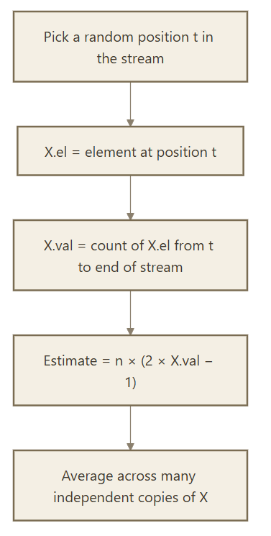

8. Counting Ones in a Window

The problem: Given a binary stream (a stream of 0s and 1s — e.g., "did event X happen at this time step?"), estimate the number of 1s in the last N elements (the most recent window), using memory that is much smaller than N, and without being able to re-scan old data.
Naive approach and why it fails: Storing the last N bits directly would need O(N) memory, and for very large windows (or many simultaneous streams/windows being tracked) this becomes infeasible.
DGIM Algorithm (Datar–Gionis–Indyk–Motwani) — the standard solution
Core idea: Instead of storing every bit, DGIM groups 1s into "buckets" and only stores, for each bucket, its timestamp (position of its most recent/rightmost 1) and its size (count of 1s it represents). This allows the count of 1s in any recent window to be estimated (with a bounded error, at most 50% in the classic version) using only O(log²N) memory instead of O(N).

Rules for maintaining buckets:
- Every bucket's size (number of 1s it represents) must be a power of 2: 1, 2, 4, 8, …
- As new bits arrive:
  - A 0 does not create a new bucket.
  - A 1 creates a new bucket of size 1, timestamped with the current position.
- At most two buckets of the same size are allowed to exist at any time (for the given window length being tracked). If a third bucket of the same size would be created, the two oldest buckets of that size are merged into one bucket of double the size (with the timestamp of the more recent of the two).
- Buckets that fall entirely outside the window of interest (based on their timestamp) are dropped.
Estimating the count of 1s in a window of size N:
- Sum the sizes of all buckets that fall (fully or partially) within the last N positions.
- For the oldest bucket that partially overlaps the window boundary, count only half of its size (since we cannot know exactly how many of its represented 1s fall inside vs. outside the window) — this is the source of the algorithm's bounded estimation error.
Error bound: The DGIM algorithm's estimate is guaranteed to be within 50% of the true count in the worst case — i.e., it is never off by more than a factor of 1.5x either direction (this can be tightened by allowing more buckets of the same size, trading more memory for more accuracy).
Use case example: Estimating "how many of the last 10,000 clicks were on an ad?" or "how many of the last N sensor readings exceeded a threshold?" using memory that grows only logarithmically with N, rather than linearly.

Example bucket layout (most recent on the left, at most 2 buckets per size):

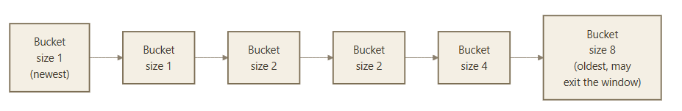

9. Decaying Window

The problem with a fixed/sliding window: A sliding window treats every element within the window equally and completely ignores anything outside it — there is a hard cutoff. Sometimes we instead want recent data to matter more than older data, but without discarding older data entirely — i.e., a smooth, gradually diminishing weighting of the past, rather than an abrupt cutoff.

Exponentially Decaying Windows
- Instead of a hard window boundary, each element is given a weight that decreases exponentially the further back in time (or the further back in the stream) it occurred.
- A common formulation: maintain a running weighted sum where, when a new element a_t arrives, the aggregate is updated as:
Aggregate_new = (1 − c) × Aggregate_old + c × a_t

where c is a small constant (the decay factor, e.g., c = 1/N for an "effective window" of roughly size N) that controls how quickly older data's influence fades.
- Effect: the influence (weight) of an element that arrived k steps ago decays proportionally to (1 − c)^k — recent elements dominate the aggregate, but old elements are never abruptly dropped; they simply contribute an ever-shrinking amount.

Advantages over a fixed sliding window:
- Requires storing only a single running aggregate value (constant memory) instead of the entire window's contents.
- Naturally adapts to emphasize recent trends — useful for applications like trending-topic detection, where "what's currently popular" should smoothly shift as interest changes, rather than jumping discretely the instant an item exits a fixed window.
- Avoids sudden jumps in the statistic that can occur with a hard sliding window when an important old element suddenly "falls off" the edge of the window.
Use case example: Identifying trending topics on social media — an exponentially decaying count of mentions per topic naturally favors topics that are being discussed right now, even if an older topic had a huge burst of mentions days ago that has since faded.
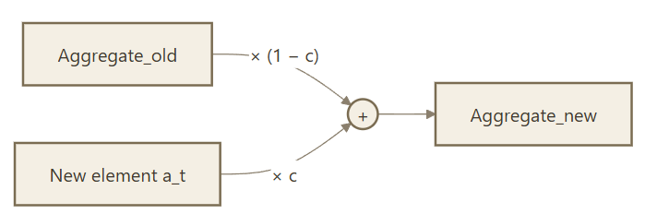

Part D — Real-Time Analytics Platforms (RTAP) & Case Studies

10. Real Time Analytics Platform (RTAP)

What is RTAP? A Real Time Analytics Platform is a system/architecture designed to ingest, process, and analyze streaming data as it arrives, delivering insights and triggering actions with minimal latency — as opposed to traditional analytics, which runs on data already stored in a warehouse (batch analytics).

Typical RTAP architecture components:
- Data ingestion layer — collects data continuously from sources (sensors, applications, social media APIs, transaction systems). Common tools: Apache Kafka, Flume.
- Stream processing engine — applies the streaming algorithms and transformations (filtering, aggregation, windowing) covered in Part C, in real time. Common tools: Spark Streaming, Apache Storm, Apache Flink.
- Storage layer — for maintaining state, historical context, or results (e.g., HBase, time-series databases, in-memory stores like Redis).
- Serving/visualization layer — dashboards, alerts, or downstream applications that consume the real-time results (e.g., live dashboards, automated trading systems, alerting systems).
Why RTAP?: Many business and operational decisions lose value if delayed — fraud must be caught within seconds, trending topics must be surfaced while they're still trending, and system failures must be detected before they cascade. RTAP architectures are what make this possible at Big Data scale, building directly on the streaming algorithms in Part C (sampling, filtering, distinct counting, moment estimation, windowed counting, decaying windows) as their computational core.

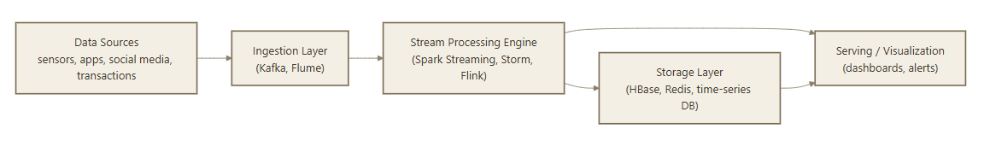

11. Case Study — Real-Time Sentiment Analysis
Goal: Continuously analyze streaming text (e.g., tweets, product reviews, customer support chats) to determine public/customer sentiment (positive, negative, neutral) as it is generated, rather than in a delayed batch report.

Typical pipeline:
- Ingestion — a stream of social media posts/comments is continuously pulled in (e.g., via a Kafka topic fed by a social media API).
- Preprocessing — each incoming text item is cleaned (removing noise, tokenizing, handling emojis/slang) as it passes through the stream processing engine.
- Sentiment classification — each item is scored using a pre-trained sentiment model (rule-based lexicon scoring, or a machine learning/NLP classifier) as it flows through — this is analogous to the operator/adapter stage in the graph-based stream model (Part A).
- Aggregation — sentiment scores are aggregated over a window (e.g., using a sliding window or a decaying window, from Part C) to produce a running "sentiment trend" for a brand, topic, or product, rather than a single static number.
- Serving — results are pushed to a live dashboard, or trigger an alert if sentiment drops sharply (e.g., a PR team is notified in near real time if negative sentiment about a product spikes after a launch).
Why streaming techniques matter here:
- The volume of social posts is far too large to store and reprocess for every update — a decaying window (Part C, §9) lets the "current sentiment" smoothly reflect the latest posts, more than the older ones, without discarding history entirely.
- Filtering (Bloom filters) can be used to quickly check whether a post mentions a brand/keyword of interest, without doing an expensive full-text search against a stored keyword list for every incoming post.

12. Case Study — Stock Market Predictions
Goal: Continuously ingest streaming market data (tick-by-tick prices, trade volumes, order-book updates, news feeds) to detect patterns and support (near) real-time trading decisions or risk alerts.
Typical pipeline:
- Ingestion — a high-velocity stream of price ticks and trade events is ingested (potentially thousands of events per second per instrument).
- Windowed aggregation — moving averages, volatility, and volume statistics are computed over sliding windows (e.g., last 5 minutes of trades) using techniques like those in Part C (counting/estimating over windows) to smooth out short-term noise while remaining responsive to trend changes.
- Anomaly/pattern detection — sudden shifts can signal unusual activity such as a large institutional trade or potential market manipulation.
- Prediction/decision layer — machine learning models (potentially retrained periodically on historical data, but scoring live on the incoming stream) generate short-term price movement predictions or trading signals.
- Action/serving — signals feed into automated trading systems, risk-management alerts, or live trader dashboards.
Why streaming techniques matter here:
- Sampling may be used to maintain a manageable representative subset of ticks for certain exploratory analyses without processing every single tick for every computation.
- Counting distinct elements / estimating moments helps track statistics like the number of distinct active traders or instruments and the skew of trading volume across them, without storing full per-entity logs.
- Because financial markets move in milliseconds, only a true streaming (not batch) architecture can support this — this is a canonical example of why RTAP exists as a distinct discipline from traditional Big Data batch analytics (recall the Analytics 1.0 → 3.0 evolution and Analysis vs Reporting distinction from Unit 4 — RTAP is squarely in the "fast, embedded, prescriptive" territory of Analytics 3.0).
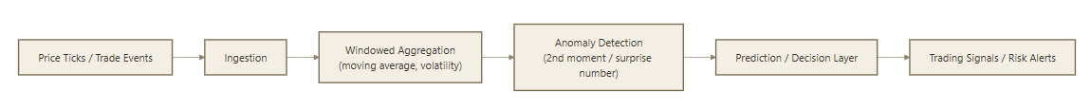

UNIT 5 Question Bank
PART – A
- What is a data stream?
- How does stream processing differ from traditional batch processing?
- What are the key characteristics of stream data?
- What is the stream data model?
- What are the major components of a stream computing architecture?
- Why is stream computing important for real-time applications?
- What is sampling in a data stream?
- How does filtering help in stream data processing?
- What are the challenges involved in processing continuous data streams?
- What is meant by counting distinct elements in a stream?
- What is the purpose of estimating moments in stream analytics?
- What is a sliding or counting window in stream processing?
- What is a decaying window and why is it used in stream analytics?
- What is a Real-Time Analytics Platform (RTAP)?
- What are the applications of real-time analytics in sentiment analysis and stock market prediction?
PART – B
- Explain the stream data model and discuss the architecture of a stream computing system.
- Describe the techniques used for sampling and filtering data streams. Explain their significance in real-time analytics.
- Explain the methods used for counting distinct elements and estimating moments in data streams.
- Discuss the concepts of counting windows and decaying windows in stream processing with suitable examples.
- Explain the architecture and applications of Real-Time Analytics Platforms (RTAP) in processing continuous data streams.
PART – C
- A social media company wants to analyze millions of user posts in real time to identify public sentiment about a product launch. Design a stream computing solution and explain the roles of sampling, filtering, windowing, and real-time analytics in the process.
Analyze how stream computing and Real-Time Analytics Platforms (RTAP) can be used for stock market prediction. Discuss the challenges involved in processing high-speed financial data streams and the techniques used to overcome them.

